5G Panoramic HD Intelligent Monitoring Camera QC-Q7

summary
The QC-Q7 Series 5G Panoramic HD Intelligent Surveillance Dome is a cutting-edge surveillance solution integrating dual HD recording, 5G transmission, voice intercom, trunked intercom, positioning services, and AI detection. Tailored to industry needs, it features a touch-sensitive display for configuring device parameters, operating pan/tilt/rotary controls, and previewing live footage. Ideal for temporary surveillance, emergency response, security monitoring, and power construction operations, this system addresses blind spots in fixed-point monitoring and ensures effective supervision of safe production activities.
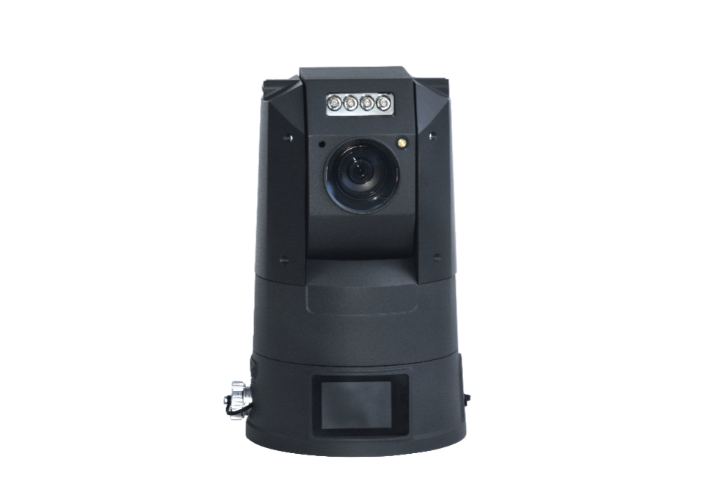

functional characteristics
Dual front and rear cameras for primary and secondary lenses
Face Recognition and License Plate Recognition
2.4-inch high-definition touch display screen
132° ultra-wide-angle camera
IP67 protection: waterproof and dustproof
The large speaker delivers clear audio.
Dual microphone for long-distance sound pickup
OnVIF protocol GB/T 28181
B interface/TF card: Multiple encryption methods
5G full-network compatibility with 4G/3G

technical parameter
project | technical parameter
Main camera version | 2 megapixels | 4 megapixels
minimal illumination | Black and white mode: 0.001 lx; Color mode: 0.0005 lx | Black and white mode: 0.01 lx; Color mode: 0.005 lx
Maximum resolution | 1920*1080 | 2560*1440
Zoom factor | 33x optical zoom, 16x digital zoom
Wide-angle camera | 8 megapixels, maximum resolution: 3264×2448; field of view: 120°
the light of a lamp | Infrared range: 100 m; customizable laser supplementary lighting with a range of 300 m
Cloud Platform | Horizontal 360°, vertical-30° to 90°,255 preset positions, supports cruise scanning
video coding | H.265/H.264
Audio Encoding | AMR/AAC/G.711
Audio Features | Built-in dual MICs and large speakers; supports hands-free microphone and Bluetooth
networking protocol | Supports TCP/IP, HTTP, DHCP, DNS, RTP/RTCP, RTSP, PPPoE, and FTP
wireless network | Two SIM card slots, supports 5G networks, and is backward compatible with 4G
Wi-Fi | Supports 2.4 GHz and AP hotspot functionality
PDA | support
show | A 2.4-inch touchscreen display for configuring device parameters, operating pan/tilt rotation, and previewing real-time footage.
memory | Dual TF cards; single card supports up to 256 GB
fixed position | Dual-mode positioning with BeiDou and GPS, supporting BeiDou 3rd generation, with positioning accuracy of 2.5 meters
Conventional AI Features | Face recognition and license plate recognition are optional.
Other AI features | Customizable safety helmet recognition and behavior analysis recognition
Interface Protocol | Supports the ONVIF protocol, GB/T 28181 protocol, and B Interface protocol.
power supply mode | Power supply: 10Ah lithium battery/DC power source
power dissipation | Maximum 20W
levels of protection | IP66
work environment | Operating temperature: -20°C to +55°C; humidity less than 95% (no condensation)
Weight and Size | Less than 4.5 kg, φ167 mm × 275 mm

application scenarios

Temporary emergency security deployment by public security authorities
Ideal for crime scenes, arrest operations, emergency response, temporary security zones, and checkpoint surveillance. The equipment features rapid deployment, 5G real-time data transmission, remote PTZ control, and AI-powered early warning systems, enabling visualized command operations.

Disaster relief and emergency command
deployed at disaster sites such as earthquakes, floods, landslides, and fires, providing real-time video feeds, voice intercom capabilities, and precise positioning to facilitate coordinated operations between frontline units and command centers in harsh environments.

Electric power construction and grid inspection
Designed for substations, transmission lines, power emergency repairs, and live-line work sites, it enables remote monitoring of construction standards and personnel operations, supports safety helmet recognition, area boundary detection, and fire/ smoke alarms, ensuring 24/7 safety surveillance.

Temporary traffic control measures
Road construction, accident response, highway checkpoints, and traffic management for large-scale events. Support license plate recognition, real-time road condition reporting, and voice-based guidance to enhance on-site response efficiency.

Security duties for large-scale events
High-density public venues such as concerts, sporting events, exhibitions, and gatherings. Provides comprehensive coverage, facial recognition capture, crowd monitoring, and abnormal behavior alerts, supporting remote security command operations.

Safety Production Supervision of Construction Sites/Mines
In construction sites, open-pit mines, and industrial park work areas, AI technology detects violations such as failure to wear safety helmets, unauthorized use of fire or smoke, boundary crossing, or leaving workstations, thereby reducing safety risks and minimizing labor requirements.

Water Resources / Rivers / Dams Inspection
River shorelines, reservoirs, dams, and flood control monitoring points are equipped with night vision patrols, remote monitoring systems, and real-time data transmission of water levels and embankment conditions, ensuring effective flood prevention duties and early hazard alerts.

Prison / Detention Center / Drug Rehabilitation Facility Monitoring
Supplemental surveillance systems are installed in prison corridor corridors, ventilation areas, entrances/exits, and isolation zones, supporting high-definition night vision, voice intercom, and behavior analysis. These systems integrate with the security platform to enable comprehensive area monitoring.

Oilfield/Petrochemical/Chemical Hazardous Materials Area
Oil and gas wellheads, pipelines, hazardous chemical warehouses, and loading/unloading areas are equipped with comprehensive monitoring systems covering all areas without blind spots, remote monitoring capabilities, and fire/ anomaly alerts, thereby enhancing the safety standards of high-risk facilities.

Temporary security for parks/property management/ports
Temporary surveillance systems are deployed in industrial parks, logistics hubs, ports, and residential communities, featuring rapid deployment and mobile flexibility. These systems support voice-based evacuation commands, video recording storage, and theft and fire prevention controls.

product superiority
- Ready-to-use upon opening, requires no wiring, ideal for temporary or emergency rapid deployment.
- 5G delivers high-speed transmission with low latency and smooth video performance
- Dual-camera system + 33x zoom + Panoramic gimbal – capturing both close-up and distant views with no blind spots
- Local touchscreen operation; it can be used independently without a platform.
- IP67 high protection rating, suitable for complex and harsh outdoor environments
- The AI algorithm is versatile and customizable to meet industry regulatory requirements.
- Compatible with national and industry standard protocols, ensuring seamless platform integration

Typical Configuration List
- 1 unit of 5G panoramic HD intelligent surveillance dome host
- Lithium battery ×1
- Power adapter ×1
- Tripod (optional)
- Product Manual ×1
- Warranty Card ×1

